Sway

Housing Need Survey Report

November 2013

Community Action Hampshire

SWAY HOUSING NEED SURVEY REPORT

Table of contents

Introduction | Page
Executive Summary | 1-2
Background information | 3-4

Sway housing need survey results | Page
Section 1: Background and general information

Introduction | 5
Survey purpose and methodology | 5-7
Response to Survey | 7
Section 2: The Survey Findings

Current Housing Situation – Key Features | 8-11
Level of support for a small development of affordable housing | 12
Housing Need | 13-19
Affordability | 19-21
Section 3: The Way Forward

Conclusion | 22-23
Recommendations | 24

Appendix | Page
Appendix 1: Sway housing need survey questionnaire | 25-32
Appendix 2: Sway housing need survey responses | 33-44
Appendix 3: Sway questionnaire results | 45-52
Appendix 4: Photographs of recent HARAH schemes | 53-55

Sway Housing Need Survey Report



EXECUTIVE SUMMARY:

SWAY HOUSING NEED SURVEY

Key features and main outcomes

- Sway housing need survey was conducted in November 2013. 1529 surveys were sent out to all households in Sway parish. Additional surveys were also posted to the applicants with a local connection to Sway on New Forest District Council’s Housing Register.

Out of these 1610 surveys distributed, 474 were returned, a 29% response.

Support for an affordable housing scheme

- 67% of survey respondents would support a small affordable housing scheme for local people in Sway. 24% may support a scheme and 8% would not support a scheme.

Local housing need

- Though most people are satisfied with their housing situation, the housing need survey recommends an affordable housing scheme of up to 15 units on one or two sites in the parish.

Housing need survey results

- 52 households with a local connection to Sway are on New Forest District Council’s housing register. This housing need survey has identified an additional 14 households interested and eligible for affordable rent.

- The survey has also identified 32 additional households interested and eligible for shared ownership.

- Sway housing need survey and housing register figures show that there is a local affordable housing need of 98 in Sway.

- Respondent households also report 445 family members, friends and acquaintances that have had to move from Sway due to difficulties in finding a suitable home locally. However, it is important to note that not all 445 individuals/households will be interested in/eligible for affordable housing.

- Housing need may arise for a number of reasons, but in the majority of cases it is because individuals or couples want to start their first home, want to be near family or cannot afford private rent/mortgage.

- There is a demand for a mix of properties in Sway; 24% of households require a one bedroom property, 42% require two bedrooms and 32% require three bedrooms.

- The majority of households in need of an affordable property in Sway are young single people, young couples and young families. 83% of individuals identified as being in housing need are under 44 years.

The survey recommendations

- It should be noted that the recommended scheme does not meet all of Sway’s housing need but the proposal of 15 units takes into account the size of the parish, the impact of a new development on the parish and resident’s views from this survey which state that a small affordable housing scheme for local people would be supported.

Residents who need to downsize

- Through discussions with the Parish Council, the Rural Housing Enabler has included questions to find out whether there is a local demand from older residents who need to downsize.

- Provision needs to be in place for Sway’s growing number of elderly residents. 2011 Census results show that 30% of residents in Sway are over 65 years.

- The housing need survey identified 46 respondents who have a requirement to downsize to a smaller property in the parish and a further 7 have explained that they may wish to downsize in the future.

Background information

Rural affordable housing for local people

- Access to affordable housing is a real concern for many residents in rural areas. Rising house prices and few homes for affordable rent often result in some members of the community having to leave their village. The number of affordable rented council properties has reduced considerably since the introduction of the government’s ‘Right to Buy’ scheme. This has resulted in demand outstripping supply.

- When people move elsewhere the result can be the closure of village schools, shops, pubs, bus routes, post offices and local businesses. It is important that communities remain vibrant and mixed and made up of people from all social strata groups.

- The affordable housing built by the Hampshire Alliance for Rural Affordable Housing (HARAH) will be specifically for people with a local connection to their parish. Before a household is offered an affordable property they will be asked to provide documentary evidence of their local connection.

- The local connection criteria and length of connection are written into the Section 106 agreement, a legal document which sets out planning conditions for the housing.

- The HARAH Affordable Housing projects help those who do not have the financial means for a mortgage, by offering them the chance to have a home, into which they have to put some equity or rent. The freehold will always remain with Hyde Housing, so that such houses would never be available on the open market.

- The waiting list for affordable accommodation has increased in recent years as more and more people are unable to afford properties on the open market, due to increasing house prices and falling incomes. The current climate means that many people are struggling to find an affordable property.

New Forest

- The average house price in the New Forest District is £222,500 compared to £203,000 in the South East and £170,000 in England (January – December 2009) (Source: Neighbourhood Statistics)

- Between 2001 and 2011 there has been a decline in the percentage of working age population from 59.2% to 58.6%. There has been a particularly large decline amongst young adults aged 25 – 39 years (from 17.6% to 14.2%).

- The 2011 Census population of New Forest District is 176,500. The population has increased by 7,100 since 2001, approximately 4.2%. Most growth since 2001 has been in the oldest age groups, the 65 and over’s increased by 15.3%.

- Total dependency has risen due to the increasing numbers of older people but child dependency has actually declined.

Dependency Ratios (2001 – 2011)

 | 2001 | 2011
Total Dependency | 68.9 | 70.7
Child Dependency | 30.7 | 28.0
Old Age Dependency | 38.2 | 42.7

- Between 2001 and 2011 the percentage of rented households increased, alongside shared and outright ownership. The percentage of households owned with a mortgage or a loan decreased by 18.2% over the period.

- (Source: the source used is the Office for National Statistics (ONS) Census 2001 (%) 2011 (%) data for the years 1981 to 2011.)

Sway

- Sway has 98 council and housing association properties. The breakdown is as follows:

Existing affordable housing stock in Sway (2011 census)
Shared ownership (part rent/part buy) | 2
Social rented from Local Authority | 61
Social rented (other) | 35
Total | 98

- 9% of the housing stock in Sway is owned by New Forest District Council or a housing association. This is low in comparison to the average for England where 18% of the housing stock is rented from the council or a housing association.

- Sway Parish has a population of 3448 residents. The table below shows the age of residents compared with the average in England. (Data taken from 2011 Census).

Age | % Sway | % England
Children under 16 years | 16.5% | 18.9%
Working age adults | 53.4% | 64.7%
Older people over 65 years | 30.1% | 16.3%

- Sway has nearly twice as many residents over the age of 65 than the average for England. Sway has an ageing population so it is important that smaller more suitable properties are provided to meet the needs of elderly residents.

- The percentage of children and working age adults is lower in Sway than the average in England. 70% of the population in Sway are under 65 years compared to 84% in England. It is likely that many young local people will have already moved out of Sway to find suitable accommodation elsewhere. Sway’s housing need survey has identified a large number of people who have had to move out of the parish due to high property prices.

SWAY HOUSING NEED SURVEY

NOVEMBER 2013

SURVEY REPORT

SECTION ONE: BACKGROUND AND GENERAL INFORMATION

1
1. Introduction

  - Following discussions with Sway Parish Council in August 2013, it was agreed that the Rural Housing Enabler at Community Action Hampshire (CAH) would carry out a housing need survey of the parish. The aim was to determine whether or not there is a need for affordable housing for local people and smaller accommodation for residents who wish to downsize.

  - The survey and this report has been conducted and produced by Community Action Hampshire (CAH). Thus, the report and the findings are an independent and impartial commentary based on the evidence collected.

  - The survey has been carried out at no financial cost to the Parish Council. The survey was funded by New Forest District Council and New Forest National Park Authority as part of their remit to explore the need for affordable housing across their planning area. The work is fully supported by New Forest District Council as the housing authority for that area. Other rural parish-based surveys are either taking place or planned.

  - This survey is the most comprehensive study of housing need undertaken in the parish. Whilst some households will already be on the District Council Housing Register, many may not be included on existing records of need. This survey also raises awareness of housing issues facing local people and gave respondents space to express their views on local housing issues.

  - The findings in this report are based on the survey only. They should be read in conjunction with other District-wide housing needs surveys, the housing market assessment, affordable housing and planning policies to place the conclusions in a district-wide, sub-regional and regional context.

  - For a wider overview of the national rural housing problem, reference should be made to the findings and recommendations of the Government’s Affordable Rural Housing Commission Final Report, May 2006 (www.defra.gov.uk)

2
2. Survey Purpose and Methodology

- The purpose of the survey was to acquire detailed information about the current housing situation and the numbers and types of households in housing need and to find out what kind of alternative housing they were seeking. The survey also gave people an opportunity to express their views on what is needed or not.

- Based on a core questionnaire, the survey form (a copy is appended to the report) was agreed by New Forest District Council and New Forest National Park Authority in its final form before distribution. The survey form was divided into three parts:
- Part 1 collected general information about the respondent’s household
- Part 2 for completion by those in housing need (the questionnaire also included an explanatory section on what is meant by affordable housing as it can be provided by housing associations together with a case study of a previous beneficiary now living in a small rural exception site)
- Part 3 collects general information about Sway Parish Council

- An important element in the design of the form was to reveal what is called hidden or concealed households, people who cannot afford to be in the housing market and are living within another household.

- The forms were delivered by mail to all households in the parish and were returned in prepaid envelopes to CAH.

- The data processing was carried out by the Rural Housing Enabler.

- As the questionnaires was sent to 100% of households, this is a total or census survey rather than a sample survey. The methodology is recommended* as being appropriate for rural areas. In the more usual borough-wide sample surveys, rural wards are grouped together and as such it is not possible to disaggregate information for individual villages or parishes. There is a presumption (Source: A Guide to Housing Needs Assessment, IOH 1993) that there will be a greater response from those in need using this methodology. The results are presented as found (no figures have been ‘grossed up’).*Assessing Housing Need in the South East – A Good Practice Guide (SEERA 2004)

- It is possible that a degree of housing need occurs within the households who did not respond to the questionnaires and therefore the need identified in this report could be an under-representation of the real situation. The actual figures from the survey can be classed as demonstrable need.

- Some information has also been cross-referenced to the 2001 Census, 2011 Census, the HM Land Registry parish-based data from web-based sites and the Office of National Statistics.

- It is hoped that this report is clear and readable. But some terms have differing definitions, not least ‘What is affordable housing?’

- We have used the following definition in this report: ‘Social rented, affordable rented and intermediate housing, provided to eligible households whose needs are not met by the market. Eligibility is determined with regard to local incomes and local house prices. Affordable housing should include provisions to remain at an affordable price for future eligible households or for the subsidy to be recycled for alternative affordable housing provision.’ (Please note that when we refer to housing association rented properties, this could be social rented or affordable rented.)

- The affordable homes are allocated to help those who do not have the financial means to meet their housing need through the housing market, by offering them the chance to have a home, into which they have to put some equity or rent. These homes will be affordable in perpetuity; such houses would never be available on the open market.

- The terms ‘house’ and ‘housing’ used in this report refers to all types of residential property including flats, bungalows, sheltered accommodation etc unless otherwise stated.

3
3. Response to Survey

- Of the 1610 questionnaires distributed, 474 were processed, a 29% response. This response is large enough to have statistical validity.

- Population figures show that approximately 3448 people live in Sway Parish (Census 2011 data). The 1529 forms distributed equate to the Council Tax Register records for the number of households validating this as a 100% survey. In addition, these figures give an average household size for the parish of 2.26 people.

- 474 survey forms were returned. 470 of these respondents answered question one which asked how many people of each age live in the home. These 470 forms represent a survey population of 1094 people, giving in average household size of 2.33 people.

- The following sections of the report analyse the key features and present the key findings from the data analysis. Appendix 1 is a copy of the survey form.

- The survey was carried out in November 2013 for three weeks before the questionnaire return date.

4
SECTION TWO: THE SURVEY FINDINGS

Current Housing Situation – Key Features

- Part 1 of the questionnaire was completed by all households whether or not there was any housing need so as to build up a picture of the current housing situation in the parish.

The Population

- 474 households replied to the housing need survey, the survey actually represents slightly more people than the 1094 recorded as 4 respondents did not answer question one.

- 15% of the total population of households represented in the survey are under 16 years. This percentage is lower than the average for United Kingdom where 18% of the population are within this age group (2011 Census results).

- 8% of the 1094 residents represented in the survey are aged 16-24 years. 2011 Census data shows that 13% of the United Kingdom’s population is within this age group.

- The survey represents 12% of residents in Sway aged between 25 and 44 years. This is low compared to the national average. Around 63 million people currently live in the United Kingdom and 27% are aged between 25 and 44 years (2011 Census data).

- 66% of residents represented in Sway’s housing need survey are over 44 years (30% are between 45 and 64 years and 36% are aged 65 years and over.)

- A large majority of residents surveyed are 65 years and over (36%). 2011 Census results show that 17% of the population of the United Kingdom are within this age group. Sway has an ageing population and the need for specialist accommodation and care and support for the elderly is going to increase as residents grow older.

- The graph below shows the age of residents who responded to the housing need survey.

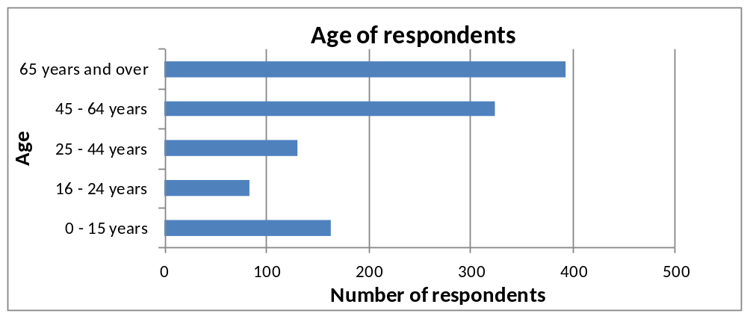

The Housing Stock and Tenure

- Sway’s Rural Place Profile (October 2013) explains that sustainable communities offer a ‘sufficient range, diversity, affordability and accessibility of housing within a balanced housing market’ .

- 89% of survey respondents live in a house or a bungalow and 78% live in properties with three or more bedrooms. Only 3% live in a one bedroom property and 19% live in a two bedroom property. With the demographic trend towards smaller households, this lack of one and two bed units will make it difficult for single people, couples, small families, first-time buyers and people on low incomes to enter into the housing market.

- Many residents may be interested in downsizing or may need to downsize in the future for health related reasons but there is an undersupply of smaller properties available in the parish.

- 84% of survey respondents own their property, with many stating that they own their property outright without a mortgage. Housing association and council accommodation (6%) and the private rented sector (6%) reflect limited opportunities for those on lower incomes unable to access the open market to rent within the parish.

- The graph below shows the tenure of households who responded to the housing need survey.

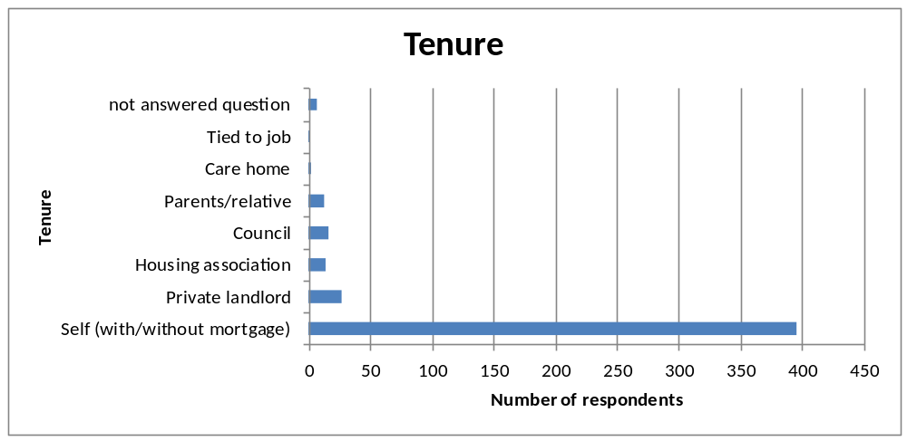
- The table below shows the tenure balance of properties in Sway in 2011 compared with the average for the New Forest and England. (Data has been taken from the 2011 Census).

- There is a high proportion of owner occupied homes in the parish and very few rented properties, which will make it difficult for local people to access a range of different tenures.

Housing tenure (%) | Sway  (%) | New Forest (%) | England (%)
Housing that is owner occupied (2011 Census) | 83.1 | 75.6 | 64.1
Housing that is rented from the council or housing association (2011 Census) | 8.9 | 11.0 | 17.7
Housing that is private rented (2011 Census) | 6.3 | 10.6 | 15.4
Other rented accommodation (2011 Census) | 0.6 | 1.5 | 1.4
Household living rent free (2011 Census) | 1.2 | 1.3 | 1.3
Shared ownership accommodation (2011 Census) | 0.1 | 0.6 | 0.8

- 2011 Census results show that 83.1% of properties in Sway are owner
occupied and 55.7% are owned outright.

- The table below shows the proportion of detached, semi-detached, terraced properties and flats in Sway compared with the average for New Forest and England. (Data has been taken from the 2011 Census).

Property type 2011 (%) | Sway  (%) | New Forest (%) | England (%)
Detached houses | 66 | 45.3 | 22.3
Semi-detached houses | 21.7 | 23.3 | 30.7
Terraced houses | 8.3 | 15.8 | 24.5
Flats (purpose built) | 0.9 | 11.2 | 16.7
Flats (other) | 2.8 | 2.7 | 5.4
Mobile home | 0.3 | 1.6 | 0.4
Second home | 1.2 | 1.6 | 0.6

- 2011 Census results show that there are three times more detached properties in Sway than the average for England. Detached properties usually have three or more bedrooms and are at the higher end of the market. There is a relatively low proportion of semi detached properties, flats and terraced properties in Sway for different ages and income groups.

Property Turnover

- The question on length of residency shows that 69% of survey respondents have lived in Sway for over 10 years with a further 15% being resident for 5-10 years. This represents a stable community, a low level of development and a low turnover of property.

Length of residency | Respondents
Under 5 years | 68
5 - 10 years | 64
Over 10 years | 299
No answer | 43

Households who need to downsize

- Across Sway, the proportion of older people in the population is forecast to increase, which reflects the national trend. This will have implications for healthcare provision and the facilities and services needed in the area in the future.

- There is often a relatively high proportion of large detached properties with three or more bedrooms in rural areas. Some older people in these communities may wish to downsize to a smaller more manageable property in the future. Smaller properties may not be available for these residents in their local community. There are three times more detached properties in Sway than in England as a whole. Older people who need to downsize may be forced to move out, many will have lived Sway all their life and will be moving away from valuable support networks.

- Through discussions with the Parish Council, the Rural Housing Enabler has included some questions to find out the needs of older residents who may wish to downsize.

- 46 respondents have explained they have a requirement to downsize to a smaller property in the parish, and a further 7 have explained that they may need to downsize in the future.

- 66% of survey respondents are over 44 years and 78% live in properties with three or more bedrooms so it is not surprising that the housing need survey has identified a demand for smaller properties for older people. It is likely that this demand will increase as residents grow older.

- The reasons why these 46 households need to move are as follows: (Please note that some respondents have given more than one answer to this question).

Reason the household has a requirement to downsize | Number of respondents
Garden too large to manage | 23
Family left home | 21
Current house too large to manage | 16
Health related reasons | 11
There is a lot to maintain in an older property | 1
Cost of maintaining current house | 1
Financial reasons | 1

- The table above shows that residents need to downsize for a number of reasons. Some are ‘empty nesters’, their children have moved out and they are looking for a smaller property while others need to move to a smaller more manageable property to suit their needs as they grow older.

5
Level of support for a Small Development of Affordable Housing

  - One of the purposes of the report was to establish the level of local support for a possible small affordable housing scheme in Sway. Question 7 on the questionnaire asked:

Would you support a small development of affordable housing in Sway if there was a proven need from residents with a genuine local connection?

67% of respondents said ‘Yes’, 8% said ‘No’, 24% said ‘Maybe’

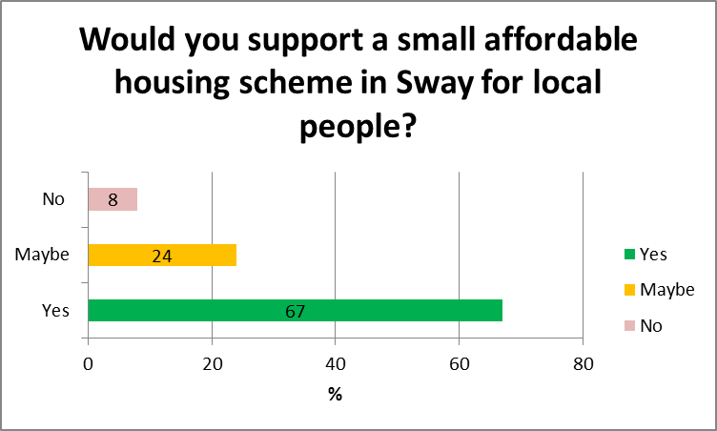

  - Numerically, this represents a majority who would support the Parish Council if a small development were needed. Many respondents backed up their decision by adding comments and I have included these in verbatim transcripts in Appendix 2

  - Many respondents who have stated they may support a scheme have explained that they will only support a development if it is on a small scale, well designed and is for local people. HARAH always build small affordable housing schemes for local people that are in keeping with the local area.

6
Housing need

People who have already had to move out of Sway because of a lack of affordable housing

  - Respondent households report 106 family members having had to move from the parish due to difficulties in finding a suitable home locally.

When the household moved out of parish | Family members
Within the last two years | 38
Within the last 2-5 years | 68

  - Respondents were also asked whether they knew of any other people who had been forced to move out of Sway. The survey has identified a further 339 individuals, couples and families who have had to move out of the parish due to a lack of suitable affordable accommodation.

  - Respondents stated the type of tenure their family members, friends or neighbours were looking for (please note that not all respondents answered this question).

Tenure family member(s), friend(s), neighbour(s) were looking for | Family member(s), friend(s), neighbour(s)
Owner occupied | 70
Rent from a housing association | 44
Rent from a private landlord | 29
Shared ownership | 19

  - Respondents stated whether their family member(s), friend(s) or neighbour(s) would like to return if suitable accommodation was available (please note that not all respondents answered this question). Survey results show that many people that have moved out of Sway would like to return.

Would the family member(s), friend(s), neighbour(s) like to return to the parish? | Number of respondents
Yes | 61
No | 4
Do not know | 40

  - This represents out-migration and is indicative of a lack of affordable housing to rent or buy. Given the very low percentage of the survey population aged 16-24 years, (8%), and this being the age group most likely to be looking at their first and affordable home, there is an indication here that this is a trend which the Parish Council may wish to address: the housing needs analysis in detail below will further justify this.

  - It must be noted that these 445 households/individuals will be seeking all types of tenure so not all will be interested in or eligible for affordable housing.

Households that need a separate home now or in the next five years

  - 115 households/individuals have expressed a need for separate accommodation in Sway in the next five years. Out of these, 91 are represented in Part 2 so this means that 24 households/individuals do not need an affordable home immediately but will need one in the next three to five years. Many of these are teenagers/young adults still living with their parents. This result shows that there will be a demand for affordable homes in Sway from the younger generation reaching adulthood in the next three to five years.

Households completing Part 2 of the survey form

Households needing accommodation within the next three years

Local connection

  - Respondents were asked to fill out Part 2 of the survey form only if they need separate accommodation within the next three years.

  - 88 respondents have stated that accommodation is required within the next three years so have completed Part 2 of the form (3 respondents completed Part 2 on behalf of 2 households in housing need). This means that 91 households have been identified as being in housing need in Part 2.

  - Housing is allocated according to housing need and it is worth emphasising that strong local connection criteria would be rigidly enforced should a scheme be proposed and advanced.

  - Survey respondents have explained that 445 local people have had to move away as they have been unable to find a suitable home locally. 36 have been represented in Part 2 and 61 would like to return to the parish but it is uncertain as to whether the others are still in housing need or whether they have settled into alternative accommodation elsewhere.

Current Tenure

  - In terms of the current tenure of those 91 households in housing need, the information is as follows:

Current tenure of households requiring accommodation within the next three years | Number of respondents
Private landlord | 35
Parents/other relative | 25
Self (with/without mortgage) | 14
Housing Association | 6
Council | 6
Employer (tied to job) | 2
Parents paying current mortgage | 1
Sofa surfing | 1
No answer | 1

  - Many households/individuals in need are either renting privately or living with relatives.

  - It is likely that the 14 households who are owner occupiers will not qualify by need for the type of provision likely to be proposed: often, these are older people living in larger houses needing to downsize but wishing to remain living in the parish. It is well worth pointing out this issue as it is one frequently encountered in rural areas and is a type of need that is not being met in the rural housing market, a point already raised in paragraph 4.16 above.

  - Some owner occupiers may be eligible for a Shared Ownership property but it depends on their individual circumstances. Owner occupiers have not been included in the final figures of need for Shared Ownership.

Preferred Tenure

  - 36 households in need would prefer to rent from a Housing Association, 21 would be interested in Shared Ownership and 31 would be interested in either option.

Households on the Housing Register

  - The New Forest District Council Housing Register (The Homesearch waiting list) - the council maintains a waiting list of people who wish to be considered for council or housing association accommodation.

  - The current ‘New Forest Council Housing Register’ figures show 52 applicants with a local connection to Sway in housing need.

Please see the table below for their local connection and the number of bedrooms they require:

 | 1 Bedroom | 2 Bedroom | 3 / 4 Bedroom
Applicants with Band A local connection | 10 | 14 | 3
Applicants with Band B local Connection | 7 | 2 | 4
Applicants with Band C local Connection | 5 | 4 | 3

- Band A: live(d)/work(ed) in parish for over 10 years or key worker performing essential service for community
- Band B: live(d)/work(ed) in parish for over 5 years, parents/siblings/adult children have lived in parish for 10 years or more
- Band C: live(d)/work(ed) in parish for over 2 years, parents/siblings/adult children have lived in parish for 5 years or more

  - Out of these 52 applicants with a local connection to Sway, 27 have a local connection to the parish of more than 10 years.

  - Some households in need may not be aware that the ‘New Forest District Council Housing Register’ exists. It is often only when a development has been agreed that people register and those who have already moved away are unlikely to remain on the register.
  - 42 households identified as being in housing need in Part 2 are on the Housing Register while 43 are not and 6 did not answer the question.

  - All households in housing need who have left their details will be sent information about how to register on The New Forest District Council’s waiting list.

Household Composition

  - Results from Part 2 of the housing need survey show that the majority of individuals in housing need are under 45 years. This is not surprising as there is a limited supply of affordable properties in Sway for young people.

  - The age profile of all individuals in need is as follows:

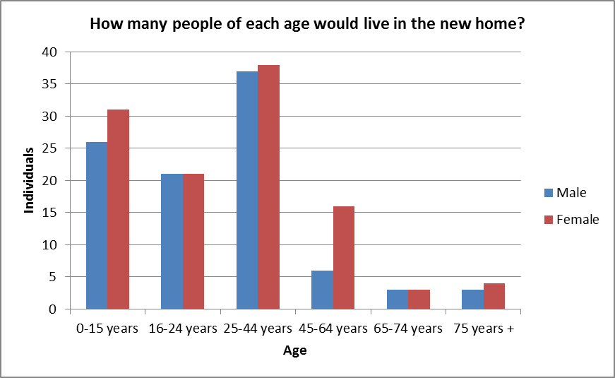
  - The majority of residents (66%) represented in Part 1 of Sway’s housing need survey are over 44 years, this is a stark contrast to Part 2 where 83% of individuals identified as being in housing need are under 44 years. This result shows that young people are particularly affected by the high property prices in Sway.

  - Looking to the future it would be beneficial to maintain a balanced community in Sway (from birth to old age) working in the local area and supporting a full range of local businesses and services. In order for this to be achieved, young people need to be able to access affordable accommodation in the parish.

Reasons Accommodation is required

  - Households in housing need require separate accommodation for a number of reasons (please note that some respondents have given more than one answer to this question).

  - The reasons why households need accommodation in Sway are as follows:

Reasons that separate accommodation is required | Response Count
Want to start first home | 33
To be near family | 26
Cannot afford rent | 23
Cannot afford mortgage | 21
Need bigger home | 17
Overcrowding | 14
Current tenure insecure | 11
Current home affecting health | 9
To be near work | 8
Divorce/Separation | 5
Special needs (e.g. disabled) | 5
Need smaller home | 3
Need independence | 2
Retiring | 1
Current property is not safe to live in | 1
House is up for sale | 1
Garden too large to manage | 1
Need ground floor accommodation | 1
In tied accommodation - this will not be forever | 1
Foster carers | 1

  - As explained in paragraph 6.25 above, the majority of people in housing need are young so it is not surprising that 33 households need an affordable home as they want to start their first home.

  - 26 households want to be near family; being close to family support networks is important for many people.

  - Households need a good annual income to afford to rent or purchase a property in rural areas so it is not surprising that 23 households cannot afford to rent and 21 cannot afford a mortgage.

  - The housing need survey has identified a demand from households living in overcrowded conditions. Many families live in inadequate accommodation in rural areas as they are unable to afford or access a suitable property. Some live in damp or overcrowded conditions and do not want to move out as they are caring for a relative or their children go to the local school. Often, the limited availability of private rented stock in rural areas means that there are no suitable properties available.

Size of Accommodation Required

  - Housing need survey results show that 24% of households require a one bedroom property, 42% require a two bedroom property, 32% require a three bedroom property and 2% require a four bedroom property.

  - The two tables below show housing need survey results and housing register figures.

  - Results vary slightly as a higher percentage of applicants on the housing register require a one bedroom property than households identified as being in housing need through the housing need survey. This is not surprising as it is likely that some respondents who have stated that they need a two bedroom property in the housing need survey may actually only be eligible for a one bedroom property.

  - 34% of survey respondents have stated they need a three bedroom property while housing register figures show that 19% of applicants require a three bedroom property.

  - Although there is some variation, both the housing need survey results and housing register figures show that there is a need for a mix of property types for single people, couples and families (one, two and three bedroom properties).

- Note: 6 respondents did not answer this question
HOUSING NEED SURVEY FIGURES  Size of accommodation required | Number of respondents | Percentage of households
One bedroom | 20 | 24%
Two bedrooms | 36 | 42%
Three or four bedrooms | 29 | 34%

HOUSING REGISTER FIGURES  Size of accommodation required | Number of applicants | Percentage of applicants
One bedroom | 22 | 42%
Two bedrooms | 20 | 38%
Three or four bedrooms | 10 | 19%
  - 2011 Census results show that 66% of properties in Sway are detached compared with 45% in the New Forest and 22% in England. Sway has 44% more detached properties than the average in England. A mix of property types are needed in Sway to ensure that different ages and income groups are able to live there.

Households requiring specialist care and support

  - Some households in need require specialist or adapted accommodation, care and/or support. (Please note that households were able to give more than one answer to this question.)

Does anyone in your home require specialist care and support? | Number of respondents
Support needed to live independently | 2
Limited mobility, wheelchair user | 6
May need an adapted bungalow in the future | 1
Child needs an adapted bungalow | 1
Infrequent wheelchair user at present but likely to become frequent | 1
May need supported housing soon as pacemaker fitted and diabetic | 1

  - The table above shows that there is a demand for specialist care and support. Sway has an ageing population and age related problems are only going to get worse. Many respondents have explained that it is likely they will need specialist care and support in the future.

Affordability 7

Market rent

  - 2011 Census results show that the percentage of households renting privately in the United Kingdom has increased from 9% to 15% since 2001. The private rented sector has increased significantly in the last 12 years as high house prices have meant that renting privately is now the only option for many households. Renting privately however, can be very expensive in rural areas.

  - On 13th January 2014, a studio flat was available to rent privately in Sway for £480 per month. The income levels needed to access the private rented sector are based on rent at 25% of gross household income, (the recommended level in National Guidance for the private rental sector). To afford this property, a household would need an annual income of £23,000.

  - On 13th January 2014, this studio flat was the only property available for rent in Sway. The next cheapest property close to Sway was a two bedroom property in Lymington priced at £800 per month. To be able to afford this, a household would need an annual income of £38,000.

  - Out of the 72 households in housing need whose annual income was declared, 39 (54%) have annual incomes of less than £20,001 so would be unable to afford the studio flat in Sway.

  - Out of these 72 households, 36 would be able to afford to rent the studio flat in Sway and 15 would be able to afford the two bedroom flat in Lymington.

Affordable rent
(A new form of tenure introduced by the current government that allows the Housing Association to charge up to 80% of market rent)

  - Results from the survey show that 67 households in need are interested in affordable rent.

  - In recent years, the government has taken steps to bring social housing rents closer to those in the private sector. Affordable rents for new tenants are set at up to 80% of the amount payable in the private rented sector. Although the affordable housing rents are higher than the old style social rent levels, they still have many advantages: (a.) a more secure tenancy than their private sector counterparts and (b.) no large scale deposits demanded at the start of the tenancy.

  - The likely average affordable rents for a newly built property in Sway in January 2014 would be in the region of £115.38 per week for a one bed property, £153.30 per week for a two bed property, £182.31 per week for a three bed property and £230.77 per week for a four bedroom property (Source: Local Housing Allowance Rates, Directgov)

  - Households unable to afford a property at an ‘Affordable Rent’ can choose to apply for housing benefit/universal credit to help pay the rent.

Shared Ownership

  - 52 households are interested in shared ownership. The minimum acceptable income threshold to be eligible for a shared ownership property is £18,000 per year. 36 households in need have sufficient income to be able to afford a property at shared ownership.

Open Market

  - Measuring average house prices in villages can be difficult due to the small number of transactions that take place. However, there is sufficient information available to give an indication of the sort of prices a new home buyer can expect to encounter in Sway.

  - On 15th January 2014, 47 properties were available to purchase in Sway ranging from £200,000 for a one bedroom apartment to £4,950,000 for a 54 bedroom detached house (data sourced from www.rightmove.co.uk).

The cheapest properties available to purchase in Sway (15.01.2014) | Asking price
One bedroom apartment | £200,000
Two bedroom bungalow | £280,000
Three bedroom house | £250,000
Four bedroom house | £275,000

  - To afford the cheapest property available for £200,000, a buyer would need at least a 5% deposit. A 5% deposit for a property priced at £200,000 would be £10,000. A mortgage for a property at this price would be £190,000. For a loan of 4.75 times annual income, an individual/couple would need a gross annual income of £40,000 (Halifax mortgages, how much could I borrow calculator).

  - Out of the 72 households in housing need whose annual income was declared, 13 would be able to afford the cheapest one bedroom property in Sway.

  - The average income for people aged 22-29 years in the UK is £21,000 (Office for National Statistics, Annual Survey of Hours and Earnings, 2012 Provisional Results). A mortgage for a property priced at £200,000 is 9.5 times the income of someone earning £21,000 per annum.

  - 36 households in need require a two bedroom property. To afford the cheapest two bedroom property currently available in Sway, a young family or couple would need a deposit of at least £14,000. To be eligible for a mortgage of £266,000, the household would need to be earning £62,000 per annum.

  - 27 households in need require a three bedroom property. To afford the cheapest three bedroom property currently available in Sway, a young family would need a deposit of at least £12,500. To be eligible for a mortgage of £237,500, the household would need to earn £56,000 per annum.

  - The majority of sales in Sway during the last year were detached properties, selling for an average price of £535,000. Semi-detached properties sold for an average of £314,000, with terraced properties selling for £185,000. Sway, with an overall average house price of £451,000 was more expensive than nearby Hordle (£267,000) and Lymington (£327,000), but was cheaper than Brockenhurst (£580,000). (www.rightmove.co.uk)

  - A deposit for a property priced at £451,000 would cost a buyer at least £22,550. To afford a mortgage of £428,450, a buyer would need a household annual income of £90,000.

SECTION THREE: THE WAY FORWARD

Conclusions 8

‘Increases in house prices, which recently have far outstripped average increases in earnings, mean that local people may be priced out of the housing market in the area in which they grew up. For a community to sustain a fair and balanced housing market, it must provide affordable housing accessible to the local community.’ Sway’s Rural Place Profile.

  - Though most households are satisfied with their housing situation, there is a demonstrable unmet housing need from local people for up to 15 units of affordable housing on one or two sites.

  - 91% of survey respondents would or may support a small scheme of affordable properties for local people in Sway. This is a positive response as the majority will support a scheme in the village. Only 8% would oppose a scheme.

  - 91 households have been identified as being in housing need in Part 2 of the survey form. These households need to move within the next three years.

  - Out of these 91 households, 67 are interested in affordable rent. 12 of these are not eligible for affordable rent as they either a.) would be able to put a large deposit down on a property or, b.) are owner occupiers. Out of the 55 households interested and eligible for a property at affordable rent in the housing need survey, 37 are already on New Forest District Council’s Housing Register.

- 52 households with a local connection to Sway are currently on the New Forest District Council Housing Register. The housing need survey has identified an additional 18 households eligible and in need of affordable rented accommodation in Sway.

  - 52 households are interested in shared ownership. Out of these 52 households, 16 do not have sufficient income to be eligible for this tenure.

- It must be noted that when asked which tenure the household would prefer, respondents were given three options: (a.) renting (housing association), (b.) shared ownership or (c.) either option. 8 households are interested and eligible for shared ownership and affordable rent. To ensure that the housing need survey is fair and no one is double counted, I have halved the number of households interested in shared ownership and affordable rent in the figures.

- 66 households require and are eligible for a property at affordable rent

- 32 households require and are eligible for a property at shared ownership

  - The housing need survey has also identified 445 family member(s), friend(s) and neighbour(s) who have had to move out of the parish in search of an affordable home. It is likely that many of these would be interested and eligible for an affordable property and would like to move back. The figure of 98 is likely to be an underrepresentation of actual local affordable housing need in Sway.

  - It should be noted that the recommended scheme does not meet all of Sway’s housing need but the proposal of up to 15 units (10 affordable rent and 5 shared ownership) takes into account the size of the parish, the impact of a new development on the parish and resident’s views from this survey which state that only a small scheme for local people would be supported.

The needs of local people who want to downsize to a smaller property

  - Many residents may be interested in downsizing or may need to downsize in the future for health related reasons but there is an undersupply of smaller properties available in the parish.

  - 46 respondents have explained they have a requirement to downsize to a smaller property in the parish, and a further 7 have explained that they may need to downsize in the future.

  - This response rate shows that as well as addressing the affordable housing needs for local people, there is also a requirement to address the needs of older people who wish to downsize particularly in an ageing population.

Recommendations 9

  - It is recommended that the Parish Council considers advancing the process to achieve a small scheme of affordable housing as proposed above by:

- accepting the findings of this report
- engaging with HARAH (Hampshire Alliance for Rural Affordable Housing) to explore the potential for programming such a scheme and its funding by the Homes and Communities Agency
- exploring potential locations and availability of any sites which the Parish Council may think appropriate.

  - In order to justify developing a small scheme of affordable housing, there must be a proven local need.
- The current ‘New Forest District Council Housing Register’ figures show 52 applicants with a local connection to Sway in housing need.
- The housing need survey has identified an additional 14 households in need and eligible for affordable rented accommodation within the next three years. This means there is a local housing need of 66 in Sway for affordable rented accommodation.
- The survey has also identified 32 additional households interested and eligible for shared ownership accommodation.
- This means that there is a local affordable housing need of 98 in Sway.
- The survey has also picked up 445 households/individuals currently living elsewhere that may like to move back into the area. It must be noted that these 445 households/individuals will be seeking all types of tenure so not all will be interested in/eligible for affordable housing.
- The housing need survey has also identified 24 households/individuals who do not need an affordable home immediately but will need one in the next three to five years. Many of these are teenagers/young adults still living with their parents. This result shows that there will also be a demand for affordable homes in Sway from the younger generation reaching adulthood in the next three to five years.

Catherine Kirkham
Rural Housing Enabler
Community Action Hampshire
January 2014

Tel: 01962 857362

Email: catherine.kirkham@actionhants.org.uk

SWAY HOUSING NEEDS SURVEY
Appendix 1
(November 2013)
Dear Householder,

Owing to the high cost of housing in this area, the Parish Council is considering whether there might be a need for additional affordable housing in Sway so that residents who cannot afford to buy or rent locally will not be forced to move away.

Affordable houses are homes that can be rented or part bought (shared ownership) from a Housing Association. The reason for providing new affordable housing is to help local people of all ages stay within, or return to, their parish and so contribute to village life and the local businesses and services it provides. Only people with a genuine local connection to the parish are eligible for these homes and there is no right-to-buy, so the houses always remain affordable for local people.

We are sending out this Housing Needs Survey to assess the demand and gauge the level of support for a small scheme of affordable homes in the parish. We are doing so with the approval of New Forest District Council and New Forest National Park Authority, whose housing officers and planners have approved this questionnaire. Catherine Kirkham, a Rural Housing Enabler with Community Action Hampshire, will be assisting us in carrying out this survey. The survey will be analysed by the Rural Housing Enabler, ensuring that all information given is kept fully confidential. She will then give a summary report to the Parish Council.

We should stress that at this stage no decisions have been made about taking a scheme forward. This will depend on the outcomes of this survey and will be subject to further discussions with residents.

This is a very important issue that we as a community have to face, so please take time to fill in this survey. Even if no one in your household or family has a housing need, we want to know your views.

Please return this form using the FREEPOST envelope provided, marked for the attention of Catherine Kirkham by Thursday 28th November 2013

If further information or additional survey questionnaires are required, please contact the Parish Clerk.

Thank You

Sway Parish Council

Clerk: Neil Gulliver
Tel: 01590 718116

Chair: Cllr B Rickman
Tel: 01590 68 2650

In association with:


Beaconsfield House
Andover Road
Winchester
Hampshire
SO22 6AT
01962 854971
www.actionhants.org.uk

Assistance filling in this survey can be provided by calling Catherine Kirkham,
Rural Housing Enabler,
Community Action Hampshire on: 01962 857362

The information that you give will be treated in the strictest confidence. No names will be included in the report to the Parish Council, New Forest District Council or New Forest National Park Authority. Data will only be seen in generalised statistical form.

Rural Affordable Housing for Local People –
What is it?

Affordable Housing means housing which is either rented or part-purchased through shared ownership, and is provided for people who cannot afford to rent or buy on the open market. Affordable houses are managed by Housing Associations, also referred to as Registered Providers.  Providing a small number of affordable homes for local people, enables those on modest incomes to remain in, or return to, the village they grew up in. This helps to ensure that a mix of ages and income groups are able to live in the community.  In some cases, new affordable housing has enabled villages to keep their local school, shop or pub. Affordable homes can play a key role in supporting these vital village services and helping to maintain thriving communities. | 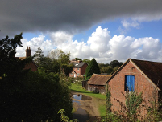  Breamore Halt,  New Forest  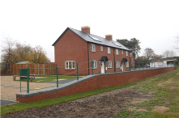
Barton Stacey, Test Valley  - Anne Drinkwater moved to Barton Stacey 47 years ago.  - Anne moved into her new 2 bedroom affordable home in the village three years ago.  - Anne was unable to purchase or rent a home on the open market.  ‘House prices have shot up over the years - they were once affordable!’  - Both Anne and her daughter work in the village, helping to keep valuable local services going.  - Anne’s family live close by and she visits them everyday. All her friends and many people she grew up with still live in the village.  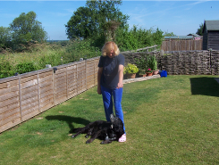  ‘The house is lovely; I wouldn’t change anything, absolutely lovely’ | Who is it for?  Rural affordable housing is for people who have a local connection to a particular village and wish to live there but cannot currently afford to buy or rent on the open market.  Local Connection Criteria  - The householder must be either currently resident in the parish and/or  - Have previously lived in the Parish and/or  - Have close family living in the parish and/or  - Work in the parish  This includes:  - Single people, couples or families unable to afford to buy or rent a home in the village because of high house prices.  - Residents who have already been forced to move away in search of cheaper rented accommodation, but who would like to move back  - People who work in the village and would like to be part of the community  If a need is identified in a Housing Needs Survey, and there is clear support from the community, affordable housing may be built on a Rural Exception Site.  Rural Exception Site - Only people with a local connection would be eligible to apply for a property.
SWAY HOUSING NEEDS SURVEY QUESTIONNAIRE
Part 1
Please complete Part 1 on behalf of your household,
(even if you do not need affordable housing).

Q1 How many people of each age live in your home? (Please write the number in the box)

Male  0-15  16-24  25-44  45-64  65+
Female  0-15  16-24  25-44  45-64  65+

Q2 What type of home do you live in?

 House  Bungalow  Flat  Caravan/Mobile Home
   Other (please specify) __________________________

Q3 How many bedrooms does your home have?

    one  two  three  four or more

Q4 Who owns the home you live in now?

 Self (with/without mortgage)  Parents/relative  Tied to job
 Housing Association  Private Landlord
 Other (please specify) _______________________

Q5 How long have you lived in the Parish? Please write the number of years below.

This home _________ years. The Parish _________ years

Q6 Do you have a requirement to downsize (move to a smaller property), but wish to stay living in the parish?

  Yes  No

If yes, what are the reasons?

 Family left home  Current house too large to
manage
 Garden too large to manage  Health related reasons
 Release some equity in current property
 Other (please specify) ____________

Q7 Would you support a small development of affordable housing in Sway if there was a proven need from residents with a genuine local connection?

 Yes  No  Maybe

Please use the space on the back page if you wish to add a comment to your answer.

Q8 How many members (if any) of your family have left this parish because of a lack of affordable housing? ________

 In the last 2 years  In the last 2-5yrs

Q9 Do you know of any other people from the parish who have been forced to move
away because they are unable to afford local house prices to rent or buy?
    
 Yes        No

If yes, how many have left this parish because of a lack of affordable housing?
________

What type of tenure were they looking for?

  Owner occupied              Rent from housing association
 Rent from private landlord  Shared ownership

Would they wish to return if suitable housing were available in the parish?

   Yes        No  Don’t know

Q10 Does anyone living in your home need a separate home now or in the next 5 years?

 No  Yes If Yes, how many? _____________

- If you or any persons with a local connection to SWAY need an affordable home and want to remain living here, or move back here, please fill in part 2

- If you are not in housing need and do not know anyone in housing need, please move on to part 3.

Part 2
Please only fill in this part if you, a family member or a friend needs a new home in the next three years and would like to live in Sway.

Q11 Does the household needing to move currently live in the parish?

 No  Yes If Yes, for how many years? _______________

Q12 If the household does not live in the parish now, what is their connection to it?
(For each box ticked please state for how long and when)

 Lived in the parish, for __________ years
 Close family have lived in the parish for _________ years (by close family we mean parents, siblings grandparents): __________________
 Have worked in the parish (full-time, part time, voluntary) for _______ years

Q13 Who owns the home you/they live in now?
 Self (with/without mortgage)  Parents/ other relative
 Private landlord  Housing Association
 Employer (tied to job)  Council
 Other (please specify) _____________

Q14 Why do you/they need a new home in this parish?

 Want to start first home  Current tenure insecure
 Divorce/Separation  Need smaller home
 Need bigger home  To be near work
 Overcrowding  To be nearer family
 Can’t afford mortgage  Retiring
 Current home affecting health  Can’t afford rent
 Special needs (e.g. disabled)  Other (please specify) _______________

Q15 How many people of each age would live in the new home? (Please put the
number of people of each age in the relevant boxes)

Male    0-15yrs  16-24  25-44  45-64  65-74  75+
Female    0-15 yrs  16-24  25-44  45-64  65-74  75+

Q16 How many bedrooms will your/their new home need? ___________

The following questions requesting financial information will be used to gauge affordability of required accommodation and for no other purposes.

Q17 How much would each ‘new’ household be able and willing to pay in rent or mortgage costs per month?

 £51 - £100 per week (£222 - £433 per month)  £101 - £150 per week (£434 - £650 per month)
 £151 - £200 per week (£651 - £867 per month)     £201 - £250 per week (£868 - £1,083 per month)
 More than £251 per week (>£1,084+ per month)

Q18 What is the household’s gross annual income (before deductions)?      
  Between £5,000 - £10,000    Between £10,001 - £15,000  Between £15,001 - £20,000
 Between £20,001 - £25,000    Between £25,001 - £30,000  Between £30,001 - £35,000
  Between £35,001 - £40,000  Between £40,001 - £45,000  Between £45,001 - £50,000
 Over £50,001

Does this include housing benefit or any other benefits?      Yes  No

Q19 If you/they are interested in Shared Ownership ,how much would you/they be able
to be put down as deposit and legal costs? £__________

Shared ownership is a scheme where you can buy a share of your home and pay rent to the Housing Association on the remaining share.

Q20 Which of the following tenures would be your/their preferred and most affordable option?

 Renting (Housing Association)
 Shared Ownership (part rent/part buy with a Housing Association)
 Either option

Q21 Does anyone in your/their household have a supported housing need?

 No
 Yes, Support needed to live independently
 Yes, Limited mobility, Wheelchair user
 Yes, Other (please specify) ______________________________________

Q22 Is the household registered on the District Council Housing Register or
       Yes If yes, what is your/their reference number?____________
 No If no, but are interested in affordable housing, please give your/their contact details below

Name: Address:

Tel: Email:

Homesearch (join the waiting list) www.newforest.gov.uk/homesearch
If you/they are interested in affordable housing and are not on the waiting list, please contact New Forest District Council on 02380 285000 or Housing Services on 02380 285234 who will be able to assist with your/their application.

Please use this space below if you wish to make further comments. You should be aware that these comments may be included, without mentioning anyone’s name, in the final report to the Parish Council.

In order to be considered for an affordable home, the household in need must be registered on the Council’s Housing Register. It is in your/their interest to register as soon as possible.

PLEASE COMPLETE PART 3 – YOUR PARISH COUNCIL
Part 3
Your Parish Council

Q23 What further services or provision would you like to see provided by Sway Parish Council?

 More support for older people
 An internet café
 Support for more musical and cultural events in Sway
 Cheaper allotments
 More allotments
 A Parish Council newssheet
 Parish Council annual report on how your money is being spent
 A planning clinic
 Support in clearing ditches and trimming hedges
 More road safety measures
 Improved quality and provision of green spaces in Sway
 Extending the summer playscheme
 Anything else within our remit (please specify) ______________________________

What would your priorities be? (Please rank in order with 1 as first choice, 2 as second choice and 3 as third choice)
- _____________________________________________________
- _____________________________________________________
- _____________________________________________________

Q24 Sway Parish Council’s current precept (Council Tax) is £28.60 per annum per entire Band D household; the average across the New Forest being more than twice that at £65.48. Most of Sway’s precept goes towards the Jubilee Field. Would you prefer to see:

  Sway’s precept go down and services go down/or prices for these services go up
  Sway’s precept, services and prices stay at the same level
 Sway’s precept go up and services extend/or prices for these services go down

Q25 Do you know who your Parish Councillors are?
  Yes  No

Q26 Do you consider yourself well informed about activities in the village
     Yes  No

Q27 Are you aware that there is a new Parish Council website serving the village?

     Yes  No

If yes, what additional information would you like to see on this website?:
………………………………………………………………………………………………………………………………………………………………………………
Thank you for completing this questionnaire.
The Parish Council appreciate your help

Appendix 2

Sway Housing Need Survey Responses

Residents in support of an affordable housing scheme
(shared ownership and affordable rent)
‘I am in the fortunate position of not needing designated ‘affordable housing’ myself but I feel strongly about the vital importance of such housing.

As is well known, young people and young families are being priced out of the market with significant repercussions both for themselves and for the social cohesion of an area.

Family support and connections risk being compromised, and family history in an area is severed.’

‘Yes, there should be more affordable housing in Sway for local people as I understand it, land off Church Lane has been offered for building houses as long as 50% is affordable. To sustain local village life, this should be considered. If no affordable homes are built, Sway will become a village full of outsiders with no local knowledge and young families having to move away.’

‘An average, working young couple cannot afford to buy in Sway. There are no low cost houses being built specifically for young local people to buy. Younger working couples do not qualify for affordable housing.’

‘It is very difficult to pay the high rent rates in this area and save for a deposit, so although we could afford a substantial mortgage, we cannot save for a deposit. We are willing to live together (mother, son and daughter in law) to enable the family to stay together and to all contribute to costs but would require a property that we could make our own which is why we would opt for a shared ownership scheme.’

‘I can see my own children having to move out of the area when they want to leave home as prices are so high and there is nowhere affordable.’

‘We need a bigger home and want to stay living in the parish for our foster children’s stability and wellbeing.’

‘I think Sway needs more housing for people like me who are on a low income. I am self-employed and cannot afford to rent privately or to get a mortgage.

I have lived in Sway for a long time, attended Sway infant school and Junior schools and had part time jobs in Sway in my teenage years.

I had to move away from Sway about fifteen years ago for employment and after that, I became unemployed but desperately wanted to move back home to set up my own business. I could not afford to rent privately or take out a mortgage so moved back in with my elderly parents.

I put my name down on the housing list which I have been on for 2 ½ years. In that time there have only been a few suitable houses that I have bid on but to no avail.

The problem is lack of properties in general but especially for young single people with no dependencies. I desperately want to stay in Sway – the place I grew up in and love and to be near my parents to help out (they are in their 70s).

My business runs from Sway and the majority of my clients that I help for lots of different reasons i.e. poor health, injury, age, live in Sway, I work really hard to make my business viable but just cannot afford to rent in Sway on my own.

A small one bedroom bungalow would be so perfect and make my life complete. PLEASE PLEASE PLEASE YES, to more affordable housing in Sway.’

‘I support a small development of affordable housing in Sway. I would prefer it to be built on a Brownfield rather than a Greenfield site.’

‘It is not necessarily a problem with income but a problem with the high cost of buying. Our friends would want to move back to Sway but live in a cheaper area at present.’

‘Both my partner and I have lived in the parish since we were five years old, that being 30 years for me. We have only just been able to afford a place of our own in the village, but it is still very expensive at over £700 per month for a middle floor flat with no garden or garage.

We would love to start a family and bring them up in Sway, but this is not looking possible at present.

All of our friends who we grew up with and went to school with have all moved away due to unaffordable housing. My parents, who still live in the village, have seen their whole family move away for the same reasons. Their road used to be full of young children out playing; now the close is childless.

The village is getting older and older; it deserves and needs affordable housing in order to maintain a healthy community.’

‘Sway, like many desirable places in the New Forest risks a polarised demographic owing to the extraordinary house prices and the limited housing stock.

Factors that don’t help the housing market and first time buyers in the village include the government’s ‘help to buy’ initiative that does not allow the market to correct itself post boom period.

Furthermore, Estate Agent ‘mafia’ trying to preserve or inflate house prices for their personal gains or the very few who are on the housing ladder. Wait for the demise of the ‘grey pound’ and next global financial meltdown and the market will have a rude awakening.’

‘I agree that there should be affordable housing and maybe the field opposite Church Lane would be suitable.

The young need to be able to stay in their environment if they wish. Do not agree with people allowed to sell their gardens for housing as it makes the village lose its charm and become ‘cluttered’.

It has been a while getting Forest Heath finished (it does look good) but who can afford the flats? Not many villagers, so outsiders will buy them as holiday homes or lets – no!’

‘I pay a ridiculous amount of money per month for a three bed house, which is now crippling me financially. I am in desperate need of affordable housing within the Sway area as I am reluctant to move away. If a property is not available soon, then I will have to seek cheaper accommodation in other areas.’

‘Yes but affordable needs to consider the reality of people’s salaries etc. Houses at £100,000 plus are not affordable for most people.’

‘Particularly for those working long term in the village.’

‘We have had three children leave as they are not able to live in the area because it is so expensive. Unfortunately, my family have moved away and started families away because they could not afford to live in the area however, I would support a development so that other families could stay.’

‘If highly controlled and only for young couples/families – villages need mix not just full of old people downsizing.’

‘I have not completed Part 2 because I do not personally know people wishing to move back into Sway but I always hear talk of people wanting to return to
Sway but are not able to due to cost.’

‘We do not need affordable housing for ourselves or family but we are aware of the need for others. Availability is key; no opportunity should be missed to secure. There is a need to utilise modern building materials and wooden frames to reduce cost. Need to adapt to local sustainability.’

‘Keeping young families residing in the village is essential to retain the balance of age range within the village. To ensure Sway remains a thriving and interesting place to live.’

‘Present accommodation is remote. We wish to return to Sway because of proximity to family and proximity to the area healthwise - we are in our 80s. We enjoyed living in Sway.’

‘Our children will be unable to buy their own home in the area, even though they work here. We need younger people to look after/service the older/wealthier people in the area and they therefore need somewhere to live without paying heavy travelling expenses.’

‘I am isolated living in Southampton away from my family and friends. My brother, his wife, nephews/nieces live in Sway and my grandparents lived there too. The schools have a good reputation and my children will benefit living close to their cousins and my mum and brother etc as they grow up.’

‘I don’t believe current planning rules. Encourage children, who marry and grow up, to return to live with parents who may need assistance in later life. Because of the 30% rule of maximum extension, properties cannot be extended any more, and often blocks the possibility of a ‘granny annex’. If more granny annexes were allowed, there would be less 3 or 4 bed properties with just one person in and less young families wanting houses.’

‘We have two children who were forced to move out of Sway with their family because of high property values and lack of shared ownership opportunities who would rather be living in Sway. They both attended Sway Primary School and two of their children currently attend this school.’

‘I fully support small developments of affordable housing in the village as I think the village needs an age/income variation in its population.’
‘I want to live in Sway but cannot afford to. I have been on the council waiting list for three years. I want to be near my family.’

‘My daughter and granddaughter would love to live in Sway and have been on the housing waiting list for three years. They have to live elsewhere in order to afford to rent. Affordable housing in Sway is really needed.’

‘We have three children – one has bought their own house locally as they are in a financial position to do so. Both my other children have married and had to move out of the area to find affordable rental properties – one to Christchurch and the other to Romsey. Both families would like to move back to the area as extended and direct family live in the area.’

‘Family have bought out of district as unable to meet cost of housing in Sway, where they would prefer to live.’

‘I grew up in Sway, moved away and have now moved back but as a family we struggle to pay the private rent. It seems nowadays, the people who can really afford to live here are people who have moved from the cities and now live here but commute to work. Village life is not what it was and it is sad that people with a real connection to the village and a rural way of life can no longer afford to be here.’

‘I have not answered section 2 because my children have already left, they could not afford to live in this area.’

‘I would be grateful to get a new home for living and working in the New Forest. My daughter is studying and is making new friends at Sway parish. As a disabled person, I would prefer my home with a garden and in a nice neighbourhood.’

‘We are very fortunate in Sway with many good services, fully support affordable housing scheme.’

‘More affordable housing!’

‘Sway was a wonderful place to grow up and I am very grateful to have had the opportunity to grow up there. I hope to be able to move back one day and raise a family there.’

‘My daughter had to move to Lymington because there was no rented housing in Sway. They have recently secured a private rented house in Sway but it is more than they can really afford as they have a young child and receive no help in benefits. My husband and his family have lived in Sway all their life but unfortunately, your own children struggle to be able to carry on living in the parish because of house prices and the lack of affordable housing for local people. My daughter’s partner also works in Sway.’

‘Affordable housing in Sway would not be needed if council houses had not been sold off cheaply in the years gone by.’

‘I have filled this in as my son lives in the village of Sway and rents private accommodation with his partner and two children and I hope this might help him.’

‘We enjoy living in the village of Sway and would welcome the opportunity to live here permanently. Our two children are squashed in one bedroom. Our landlady is 83 and when she passes away, sadly, we will have to leave this lovely village.’

‘The village does not have any space. There are new builds going on up Manchester Road – sale price I believe is £1,000,000. It could have been used for affordable housing instead!’

‘It would help if planning permission was only granted for affordable housing. Opposite where I live in Manchester Road is a large secluded site which would take several small houses but planning has only been granted for two very large houses. I called about provision for affordable housing and was told there could be some but it turns out this wouldn’t be on the same site – possibly not even in Sway.’

‘Bring young people to Sway.’

‘I believe I am typical of the type of person you are trying to help. I am locally employed, divorced, single mum – sole breadwinner. I have lived in the New Forest for a long time and work locally. I have rented in a few New Forest villages. I have no idea where I will live in the future as I cannot afford this house without housing benefit and my children really want me to stay locally as this is their home. My situation is incredibly difficult even though I have a good job and landlord.’

‘I am living in a one bedroom flat with my daughter. We urgently need a two bedroom house/flat. Our flat is far too small for us – please help.’

‘Parents have lived in Sway for around 25 years but I have been unable to afford to live here in the past. Now I have a daughter, I need mum’s help but I am struggling to afford to stay afloat financially due to high costs of rent and council tax for Sway. If there is no help available, we will have to move away again.’

‘More needs to be done to address housing in the village.’

Residents in support of smaller properties for downsizers
‘In addition to younger families, we should also consider older people who, rightly, wish to stay in their area but who would welcome the opportunity to affordably ‘downsize’ thereby freeing up accommodation/housing for families.’

‘I would like to downsize to a smaller property. A new (ish) bungalow or similar but none available.’ (Elderly man 75 years +)

‘Nationally and locally, there is a need for reasonably priced ‘bungalows’ for older people to move into. In my neighbourhood, there are at least three widows/widowers occupying 4 bedroom houses who could ‘downsize’ if suitable properties were available.’

‘Although we do need affordable housing for our young people to stay in our village, we also need affordable houses to buy for our older residents who would like to stay in the village and downsize to two bedroom properties or modest three bedroom properties.

Unfortunately, some two bed or cheaper three bed housing that comes up for sale often become second homes or holiday homes. We also have enough high price homes and need more affordable modest ones to be built.’

‘Although disabled, I am able, with assistance from my son, who lives nearby, to continue living where I am – but quite how long this situation will continue I am not able to say. After 28 years, I am not anxious to move.’

‘Please can you consider houses/bungalows for someone like me? I have the money, need to downsize for health reasons. I do not claim any benefits or help. I have worked all my life.’

‘I don’t believe current planning rules. Encourage children, who marry and grow up, to return to live with parents who may need assistance in later life. Because of the 30% rule of maximum extension, properties cannot be extended any more, and often blocks the possibility of a ‘granny annex’. If more granny annexes were allowed, there would be less 3 or 4 bed properties with just one person in and less young families wanting houses.’

‘I live in a mobile home and have my name down on the housing register thinking of my old age when I can’t drive anymore.’

Residents who may support an affordable housing scheme
‘Any new development needs to be highly considered not just in the immediate future but how a development would evolve in the future. Many houses created for affordable housing in a short time after building become ‘non-affordable’ as people leave and quite happily take a huge return on a small investment.’

HARAH’s answer: Properties built by HARAH will continue to be affordable for local people; they can never be sold or rented on the open market
‘I lived much of my childhood on a Council Estate ugly, run down and in poor state of repair.’

HARAH’s answer: HARAH works closely with the Parish Council to ensure that properties are in keeping with the local area. Please see Appendix 4 for photographs of completed schemes.
‘I have answered ‘maybe’ for this question as it all depends on the actual number and location.’

HARAH’s answer: Affordable housing schemes are on a small scale as it would be against planning policy to build a large scheme that would swamp a village.
‘The school is already fully subscribed and the doctor’s surgery is always busy and you cannot often be seen as quickly as you would like. So I don’t think the local infrastructure supports a large affordable housing development.’

HARAH’s answer: HARAH builds small schemes of affordable homes. The affordable homes are for local people and many will already be living in Sway so will be using its services and amenities.
‘I would support this initiative only if the “no right to buy” for non-locals can be guaranteed, not only now but in future years. I am not sure that this has been tested in the council yet. If this can be guaranteed, I would support the initiative.’

HARAH’s answer: Properties built by HARAH will continue to be affordable for local people; they can never be sold or rented on the open market
‘We support a small development of affordable homes for local people but it would be dependent on the chosen location.’

HARAH’s answer: HARAH works with Parish Council to ensure that schemes are located in the right area.
‘Broadly in favour of affordable housing provision but not if valuable green space is to be sacrificed.’

HARAH’s answer: HARAH works with Parish Council to ensure that schemes are located in the right area.
‘Would support if not using Greenbelt land. The fields and forest around the village are the main reasons. Sway is a nice place to live. So please do not allow them to be built on. There are many non Greenbelt areas within this part of Hampshire that should be used.’

HARAH’s answer: HARAH works with Parish Council to ensure that schemes are located in the right area.
‘Maybe, depending where – not on any Greenfield site e.g. Church Lane!’

HARAH’s answer: HARAH works with Parish Council to ensure that schemes are located in the right area.
‘Maybe ‘yes’ to housing but not on a Greenfield site or in New Forest’s National Park.’

HARAH’s answer: HARAH works with Parish Council to ensure that schemes are located in the right area.
‘Yes, if sympathetically situated.’

HARAH’s answer: HARAH works with Parish Council to ensure that schemes are located in the right area.
‘It depends where the affordable homes are to be built and also the number of houses and the look of the development.’
HARAH’s answer: HARAH works with Parish Council to ensure that schemes are located in the right area. HARAH builds small scale developments as it would be against planning policy to build a large scheme that would swamp a village. HARAH works with the Parish Council to ensure that properties are in keeping with the area.
‘Affordable housing in the past e.g. in Brockenhurst has not been allocated to local families in some cases and has been used for the benefit of outsiders. Also, 2 and 3 bedroom houses allocated to single parents moving out of the family home to have a baby, whilst desperate families still on waiting lists locally.’
HARAH’s answer: Only people with a local connection to Sway will be housed in an affordable property built by HARAH. By local connection we mean people who either live, work, previously lived or have close family living in the parish.
‘If a housing development is carried out, I hope consideration will be given that the surgery can cope with any extra people living in Sway. Also the ability of Sway to cope with all the extra people.’

HARAH’s answer: Many people in housing need will already live in Sway so already use local services.
‘Yes, but not to be too cramped.’

HARAH’s answer: HARAH works closely with the Parish Council to ensure that the development is in keeping with the area.
‘Any affordable housing should be in small groups and occupants should continue to meet ‘local connection’ criteria whilst occupying property.’

HARAH’s answer: HARAH build small scale developments and properties will remain affordable for local people.
‘Yes, answer is dependent on the site on which they would be built – no more green sites please for building’

HARAH’s answer: HARAH works with Parish Council to ensure that schemes are located in the right area.
‘Maybe, if the homes are built in keeping with the village style (not a modern box)’

HARAH’s answer: HARAH works closely with the Parish Council to ensure that the development is in keeping with the area.
‘This depends on plans for development of infrastructure in the village. Currently there are daily problems with parking and school access due to the number of vehicles etc. It also depends on the size of the development – bit of a NIMBY thing here.’

HARAH’s answer: the scheme will be on a small scale as large scale developments are against planning policy in villages, many households in need will already live in the parish.
‘Supportive of affordable housing but this is dependent on where the properties are built and how they will look.’

HARAH’s answer: HARAH works closely with the Parish Council to ensure that the development is in keeping with the area.
‘I would only support an affordable housing project if it was built in a suitable (attractive and traditional) style, on a plot currently used for housing and could not be sold on to make money.’
HARAH’s answer: HARAH works closely with the Parish Council to ensure that the development is in keeping with the area.

Residents who are not in support of an affordable housing scheme
‘Historically people are fearful of these schemes because of poor management by housing associations. We have personal experience of these tenants. They feel that they can do what they like once they have secured the tenancy.’

‘As a newcomer, I think the village has good basic facilities, but it is very built up and larger plots even split. Every space seems to be taken up and built on. I cannot see where new housing/flats could be comfortably or aesthetically appropriate. I would support housing using current houses for schemes, but no new builds here.’

‘It is appalling that there should be favouritism shown to those with a local connection. Those brought up in Sway have had opportunities afforded to only a small percentage of the population. To continue this privilege into adulthood is socially and morally reprehensible.

There should be a level playing field between those who have had a privileged upbringing and those who have not. If my children are unable to compete with those from less fortunate backgrounds, so be it.

Middle class parents, outstanding primary school etc in Sway is sufficient advantage already for those with ‘connections’. Living in one of the nicest and so most expensive places in the country should not be a lifetime ‘birthright’. I have worked very hard to be able to live here and I utterly reject the idea others should get a huge discount just because of who their parents were.’

‘Providing affordable housing for those with a local connection is not a good idea and I strongly oppose it. Unaffordable housing is a national problem caused by successive governments stealing from future generations by encouraging unsustainable debt. Local housing will just make things worse – for the privileged few with ‘connections’.

‘No, because it is too easy to swap from a different parish.’

‘Against use of beautiful fields / land being used for housing where in the past, would not have been the case.’

‘No more green areas should be developed. Too much has already been given over to expensive luxury housing – which should not have been allowed if the council were aware of a shortage of affordable housing.’

‘Affordable housing is a bad policy and should be abandoned. It does little to help the problem – reasons: it tends to encroach onto the countryside to its detriment, it ultimately forces house prices up, benefits are very peripheral.’

‘I am aware that some people get affordable housing with very dubious or lose connections.’

Other
‘I hope consideration will be given to properties suitable for disabled people. They are hard to find in Sway as we all know.’

Suggestions
‘This questionnaire should also have covered local employment, community and apprenticeships available in the parish.’

‘When siting affordable housing consider ‘parking’ of trade vehicles (tenants and services).’

‘It would be a good idea to sell the social club and build affordable housing with the garages or off-street parking’

‘Eco houses – affordable housing means sustainable eco-friendly housing – i.e. super insulated, double glazed, solar gain, water harvesting, solar cell roofing, solar panel water heating using environmentally friendly materials. Heat exchange systems. All houses in Sway should be super insulated to reduce demands on fuel and to reduce carbon footprint of the entire village. This is going to be a requirement made by the European community. We could develop a community that can self-build using wood from the forest and strawbale resources.’

‘I would prefer to see one or two houses being built amongst the existing housing stock instead of larger numbers e.g. two affordable houses linked with Forest Heath and two linked with Peppercorn.’

Appendix 3

Sway Housing Need Survey Responses

Sway - Questionnaire Results (474 forms returned) 1610 delivered

(Please note that the percentages are to the nearest Decimal Place so they do not always add up to 100%)

PART 1

Q.1 Age Profile of Survey Respondents

GENDER AND AGE | VALID  FREQUENCY PERCENTAGE
Male 0 - 15  Male 16 - 24  Male 25 - 44  Male 45 - 64  Male 65 + | 84  51  59  146  181 | 7.68  4.66  5.39  13.35  16.54
MALE TOTAL | 521 | 48%
Female 0 - 15  Female 16 - 24  Female 25 - 44  Female 45 - 64  Female 65 + | 79  32  72  178  212 | 7.22  2.93  6.58  16.27  19.38
FEMALE TOTAL | 573 | 52%
TOTAL | 1094 | 100%
4 respondents did not answer this question

Q.2 Type of Home

VALID
FREQUENCY PERCENTAGE
House  Bungalow  Flat  Caravan/Mobile Home  Other | 338  87  20  5  24 | 71.31  18.35%  4.22%  1.05%  5.06%
 | 474 | 100%

Q.3 Bedrooms in Homes – Frequency and Percentage

VALID
FREQUENCY PERCENTAGE
One Bed  Two Beds  Three Beds  Four or more Beds | 16  86  197  164 | 3.46%  18.57%  42.55%  35.42%
TOTAL | 463 | 100%
11 respondents did not answer this question

Q.4 Who owns the Home you live in now?

 | FREQUENCY | VALID  PERCENTAGE
Self (with/without mortgage)  Housing Association  Private Landlord  Parents/relatives  Tied to job  Care home  Council | 396  14  27  12  1  2  16 | 84.62  2.99  5.77  2.56  0.21  0.43  3.42
TOTAL | 468 | 100%
6 respondents did not answer this question

Q.5 How long have you lived at your address?

VALID
FREQUENCY PERCENTAGE
Under 5 years  5 – 10 years  Over 10 years | 68  64  299 | 15.78  14.85  69.37
TOTAL | 431 | 100%
43 respondents did not answer this question

Q6. Do you have a requirement to downsize (move to a smaller property), but wish to stay living in the parish?

VALID
FREQUENCY PERCENTAGE
Yes  No  Maybe | 46  421  7 | 9.70  88.82  1.48
TOTAL | 474 | 100%

If yes, what are the reasons? (Respondents were able to give more than one answer for this question)

VALID
FREQUENCY PERCENTAGE
Family left home  Garden too large to manage  Release some equity in current property  Current house too large to manage  Health related reasons  There is a lot to maintain in an older property  Cost of maintaining current house  Financial reasons | 20  23  19  16  11  1  1  1 | 21.74  25.00  20.65  17.39  11.96  1.09  1.09  1.09
TOTAL | 92 | 100%

Q7. Would you support a small development of affordable housing in Sway if there was a proven need from residents with a genuine local connection?

VALID
FREQUENCY PERCENTAGE
Yes  No  Maybe | 319  40  115 | 67.30  8.44  24.26
TOTAL | 474 | 100%

Explanation to answers to Question 7

The explanations as to why respondents have answered Yes or No to Question 7 are printed at Appendix 2.

Q8. How many members (if any) of your family have left this parish because of a lack of affordable housing?

Respondents report 106 family members who have left the parish due to a lack
of a lack of affordable housing. 38 have left in the in the last 2 years and 68 have left
in the last 2-5 years.

Q9. Do you know of any other people from the parish who have been forced to move away because they are unable to afford local house prices to rent or buy?

Respondents report 339 individuals, couples and families who have been forced to
move away due to a lack of affordable housing.

What type of tenure were family member(s), friend(s) and
neighbour(s) looking for?

VALID
FREQUENCY PERCENTAGE
Owner occupied  Looking to rent from private landlord  Looking to rent from housing association  Looking for shared ownership | 70  29  44  19 | 43.21  17.90  27.16  11.73
TOTAL | 162 | 100%
Not all respondents who have stated that family member(s), friend(s) or neighbour(s) had moved out answered this question

Would they wish to return if suitable accommodation was
made available in the parish?

VALID
FREQUENCY PERCENTAGE
Yes  No  Don’t know | 61  4  40 | 58.10  3.81  38.10
TOTAL | 105 | 100%
Not all respondents who have stated that family member(s), friend(s) or neighbour(s) had moved out answered this question

Q.10 Does anyone in your home need a separate home, now or in the next five years?

115 households/individuals have expressed a need for separate accommodation in Sway in the next five years. Out of these, 91 are represented in Part 2 so this means that 24 households/individuals do not need an affordable home immediately but will need one in the next three to five years. Many of these are teenagers/young adults still living with their parents. This result shows that there will be a demand for affordable homes in Sway from the younger generation reaching adulthood in the next three to five years.

PART 2

The following questions were answered only by those who need a new home in the next three years and want to live in Sway.

Q.11 Does the household needing to move, currently live in the parish?

VALID
FREQUENCY PERCENTAGE
Yes  No | 50  36 | 58.14  41.86
TOTAL | 86 | 100%
5 respondents did not answer this question

Q.12 If the household does not live in the Parish now, what is their connection to it?
(Respondents were able to give more than one answer to this question)

VALID
FREQUENCY PERCENTAGE
Previously lived here  Close relative has lived here  Have worked in the parish  Friends in Sway | 33  31  15  1 | 41.25  38.75  18.75  1.25
TOTAL | 80 | 100%

Q.13 Who owns the home you/they live in now?

VALID
FREQUENCY PERCENTAGE
Self (with/without mortgage)  Private landlord  Employer (tied to job)  Parents/other relative  Housing Association  New Forest District Council  Parents paying current mortgage  Sofa surfing | 14  35  2  25  6  5  1  1 | 15.73  39.33  2.25  28.09  6.74  5.62  1.12  1.12
TOTAL | 89 | 100%
2 respondents did not answer this question

Q.14 Why do you/they need a new home in this parish?

FREQUENCY VALID
PERCENTAGE
Want to start first home | 33 | 17.93
To be near family | 26 | 14.13
Cannot afford rent | 23 | 12.50
Cannot afford mortgage | 21 | 11.41
Need bigger home | 17 | 9.24
Overcrowding | 14 | 7.61
Current tenure insecure | 11 | 5.98
Current home affecting health | 9 | 4.89
To be near work | 8 | 4.35
Divorce/Separation | 5 | 2.72
Special needs (e.g. disabled) | 5 | 2.72
Need smaller home | 3 | 1.63
Need independence | 2 | 1.09
Retiring | 1 | 0.54
Current property is not safe to live in | 1 | 0.54
House is up for sale | 1 | 0.54
Garden too large to manage | 1 | 0.54
Need ground floor accommodation | 1 | 0.54
In tied accommodation - this will not be forever | 1 | 0.54
Foster carers | 1 | 0.54
TOTAL | 184 | 100%

Q.15 How many people of each age will live in the new home?
VALID
FREQUENCY PERCENTAGE
Male 0-15  Female 0-15 | 5126  31 | 12.44  14.83
0-15 YEARS TOTAL | 57 | 27.27
Male 16-24  Female 16-24 | 21  21 | 10.05  10.05
16-24 YEARS TOTAL | 42 | 20.10
Male 25-44  Female 25-44 | 37  38 | 17.70  18.18
25-44 YEARS TOTAL | 75 | 35.88
Male 45-64  Female 45-64 | 6  16 | 2.87  7.66
45-64 YEARS TOTAL | 22 | 10.53
Male 65-74  Female 65-74 | 3  3 | 1.44  1.44
65-74 YEARS TOTAL | 6 | 2.88
Male 75 years +  Female 75 years + | 3  4 | 1.44  1.91
75 YEARS + TOTAL | 7 | 3.35
TOTAL | 209 | 100%

Q.16 How many bedrooms will your/their home need?

VALID
FREQUENCY PERCENTAGE
One bedroom  Two bedrooms  Three bedrooms  Four bedrooms | 20  36  27  2 | 23.53  42.36  31.76  2.35
TOTAL | 85 | 100%
6 respondents did not answer this question

Q.17 How much would each ‘new’ household be able and willing to pay in rent or mortgage costs per month?

VALID
FREQUENCY PERCENTAGE
£51-£100 per week  £101-£150 per week  £151-£200 per week  £201-£250 per week  £251 + per week | 39  29  16  4  3 | 42.86  31.87  17.58  4.40  3.30
TOTAL | 91 | 100%

Q.18 What is the household’s gross annual income before deductions?

VALID
FREQUENCY PERCENTAGE
Between £5,000 and £10,000  Between £10,001 and £15,000  Between £15,001 and £20,000  Between £20,001 and £25,000  Between £25,001 and £30,000  Between £30,001 and £35,000  Between £35,001 and £40,000  Between £40,001 and £45,000  Between £45,001 and £50,000  Over £50,001 | 13  18  8  9  8  4  2  2  6  5 | 17.33  24.00  10.67  12.00  10.67  5.33  2.67  2.67  8.00  6.67
TOTAL | 75 | 100%
16 respondents did not answer this question

Q.19 If you/they are interested in shared ownership, how much would you/they be able to put down as a deposit/legal costs?

VALID
FREQUENCY PERCENTAGE
Under £1,000  £1,001 - £2,000  £2,001 - £3000  £3,001 - £5,000  £5,001 - £10,000  £10,001 - £15,000  £15,001 - £20,000  Over £20,000 | 2  4  1  4  8  3  3  3 | 7.14  14.29  3.57  14.29  28.57  10.71  10.71  10.71
TOTAL | 28 | 100%

Q.20 Which of the following tenures would be your/their preferred and most affordable option?

VALID
FREQUENCY PERCENTAGE
Renting Housing Association  Shared Ownership  Either option | 36  21  31 | 40.91  23.86  35.23
TOTAL | 88 | 100%
3 respondents did not answer this question

Q.21 Does anyone in your home have a supported housing need?

VALID
FREQUENCY PERCENTAGE
Support needed to live independently  Limited mobility, wheelchair user  May need an adapted bungalow in the future  Child needs an adapted bungalow  Infrequent wheelchair user at present but likely to become frequent  May need supported housing as pacemaker fitted and diabetic | 2  6  1  1  1  1 | 16.67  50.00  8.33  8.33  8.33  8.33
TOTAL | 12 | 100%

Q.22 Is the household registered on the NFDC Housing Register?

 | FREQUENCY | VALID  PERCENTAGE
Yes  No | 42  43 | 48.41  50.59
 | 85 | 100%
6 respondents did not answer this question

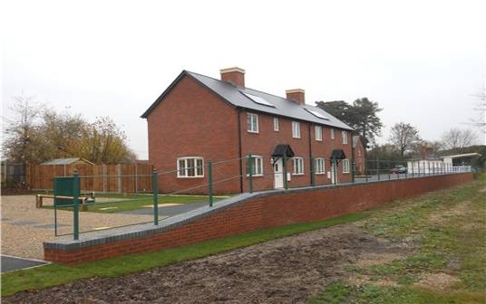
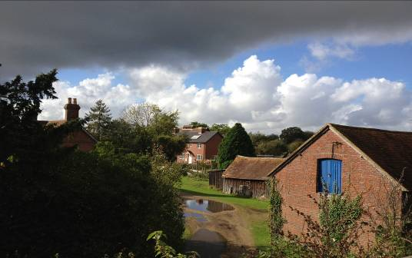
Breamore Halt, New Forest, 5 affordable properties for local people.
Appendix 4
Breamore Halt, New Forest
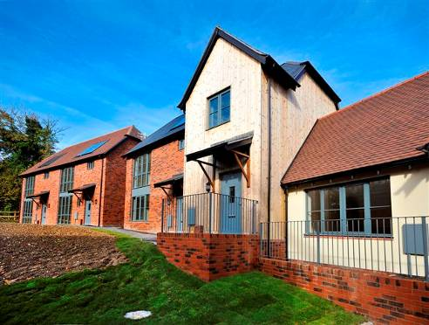
West Meon, Winchester
10 affordable homes

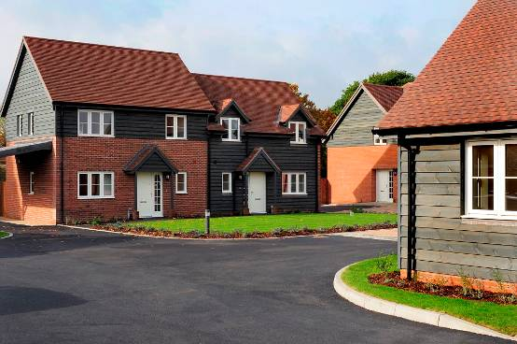
Boldre, New Forest
9 affordable homes

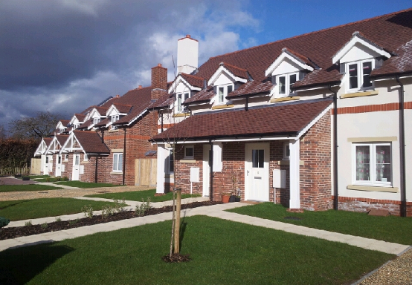
Bentley, East Hampshire
9 affordable homes

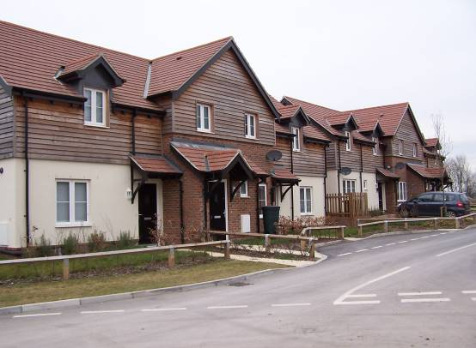
Twyford, Winchester
15 affordable homes

All schemes are different, Hyde works closely with the community to ensure that the schemes are in keeping with the style of the properties and individual character of the area.

